Project Workshop – CMPP264 Java

Topic:
Development of an object-oriented desktop application using Java, JavaFX, and a database.

Description:

In an earlier phase of the Travel Experts prototyping project you had been asked to create a sample application using C# with an MS-SQL Server database. The Travel Experts’ managers were impressed with what they saw at your presentation, but one of them read an in-flight magazine about Java and Open-Source technology while on a business trip recently and they would like to see how it compares to the C# prototype. Your task is to build an application using Java and an Oracle or MySQL database which has been provided for this purpose.

Since your team has a number of developers, you must collaborate to determine the workload and overall design, and divide the work evenly among the team members to ensure that everyone has an equal share of the workload.

To facilitate organizing the team, one person should act as the team leader and coordinate the assignment of tasks, and monitor the completion of those tasks. It is also recommended that the team use a central repository such as Git to store the master copy of the software to avoid accidental overwrites.

The Requirements of the Prototype:

In order that employees of Travel Experts can administer the data stored on their database, they need an application that will provide a graphical interface for viewing and modifying the data. At this point, they are just looking for a prototype to demonstrate the technology, so there is no specific set of data that they are targeting. What they would like your team to do is select a couple of tables such as customers, bookings, travel packages, products, etc. and build a GUI front-end using JavaFX that will enable them to maintain their data. Another possibility is to provide an invoicing feature that will generate invoices for new bookings, perhaps emailing them to the customer. They will leave the exact design up to your team.

The database that will be used for this workshop is the TravelExperts MySQL or Oracle database. The SQL import file for MySQL is on the network in the PROJ207 Threaded Project folder. If you choose to use Oracle there is an Oracle import file in the PROJ207 folder. While the database will work as it is, your team is free to make improvements to the existing database structure if your application needs it.

You are free to design the interface in whatever layout your team chooses, just keep in mind that this is a training exercise to produce a prototype and does not need to be production-ready, so don’t work yourselves to exhaustion.

Evaluation:
Each person will be assigned a grade for the workshop based on their contribution to the application. Work will be conducted in teams.

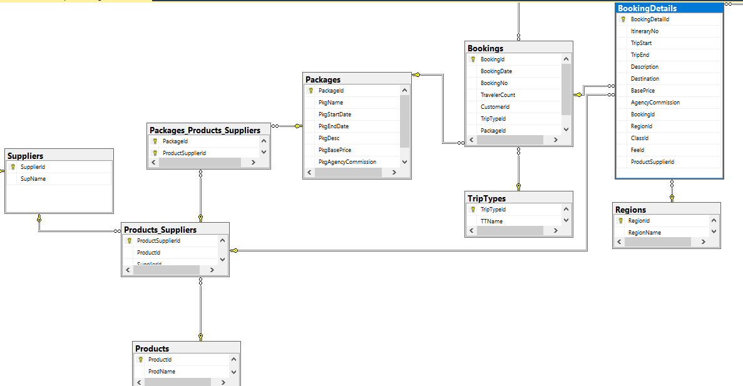
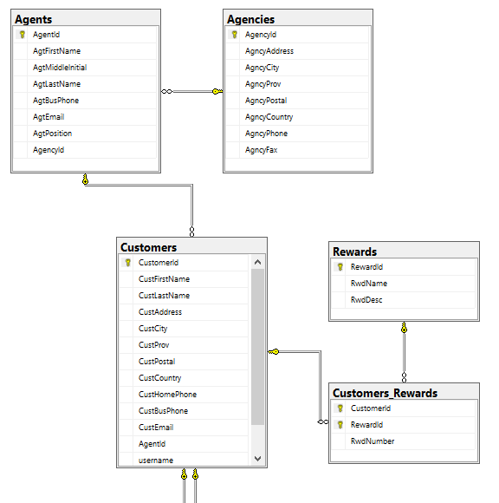
Each member must write a share of the code for the project, and each member must clearly identify which code they wrote so that they will get credit for their work when the workshop is being marked.

Factors included in the marking include code neatness and readability, documentation, functionality, and design. In cases where more than one person collaborated on a single program, each person can hand in a copy of the code with internal comments indicating which portions were written by which person. There will be many tasks that do not result in program code such as project management and testing. Please list the ones you did in a documentation file so you can be given credit for your work.

Class Time Guideline:
This is to be done as a homework assignment after 3pm. One day during the Java course will be provided as a workshop work-day. Time (approximately two days) will be provided prior to the presentation day to wrap-up the work and prepare the presentation.

Project Deliverables:
- Source code – your files should be zipped into one file, clearly named to indicate the workshop module and your name.

Due:
The project deliverables described above are due at 8:00 a.m. on the Monday following the date scheduled for the final Project Presentation, unless otherwise indicated by the instructor.

